

TRIBHUVAN UNIVERSITY

**JANAPRIYA MULTIPLE CAMPUS**

Simalchaur,Pokhara-8,Nepal

DEPARTMENT OF INFORMATION MANAGEMENT

**LAB REPORT**

Submitted To:

**MR.PRITHVI RAJ PANERU**

Java Programming-II

Submitted by:

**KRISHNA LUHARUKA**

5th Semester

Exam Roll No:12435/20

May, 2023

**INDEX:**

|  |  |  |  |  |  |
| --- | --- | --- | --- | --- | --- |
| SN | Topic | Date of Experiment | Date of submission | Signature | Remark |
|  |  |  |  |  |  |
|  |  |  |  |  |  |
|  |  |  |  |  |  |
|  |  |  |  |  |  |
|  |  |  |  |  |  |
|  |  |  |  | . |  |
|  |  |  |  | . |  |
|  |  |  |  |  |  |

**EXPERIMENT: 1**

**1.TITLE:**

A java program of local applet.

**2.OBJECTIVE:**

1. To run applet program using applet viewer.
2. To run applet program using HTML file.

**3.THEORY:**

An applet is a Java class that extends the java.applet.Applet class and runs in web browser. A JVM is required to view an applet and applet have strict security rules that are enforced by web browser.

3.1. LIFE CYCLE OF AN APPLET:

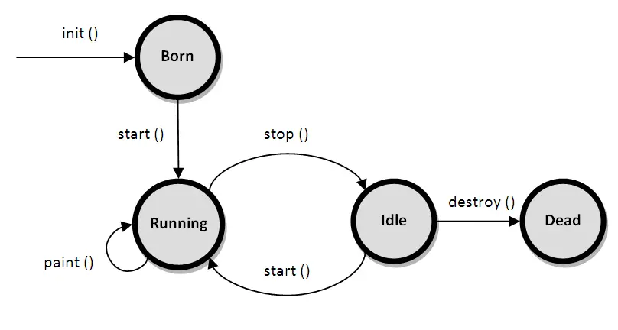

3.2. AN APPLET SKELETON:

*import java.awt.*;*

*import java.applet.*;*

*/*<applet code="Appletskeleton" width="300" height="300"></applet>*/*

*public class Appletskeleton extends Applet*

*{*

*public void init()*

*{ //initialization*

*}*

*public void start()*

*{ //start or resume execution*

*}*

*public void stop()*

*{ //suspends execution*

*}*

*public void destroy()*

*{ //perform shutdown activities*

*}*

*public void paint(Graphics g)*

*{ //redisplay contents of window*

*}*

*}*

**4.IMPLEMENTATION:**

PROGRAM 4.1. An applet program using applet viewer tool.

*import java.applet.*;*

*import java.awt.*;*

*public class Myapplet extends Applet*

*{*

*public void paint(Graphics g)*

*{*

*g.drawString("Geeky Shows",50,10);*

*g.setColor(Color.GRAY);*

*g.drawLine(20,20,20,80);*

*g.drawRect(50,20,50,20);*

*g.drawOval(110,20,20,20);*

*g.drawArc(140,20,30,30,30,90);*

*g.setColor(Color.black);*

*g.fillRect(50,50,50,20);*

*g.fillOval(110,50,20,20);*

*g.fillArc(140,50,30,30,30,90);*

*}*

*}*

*/*<APPLET code="Myapplet" width="250" height="180"></APPLET>*/*

OUTPUT:

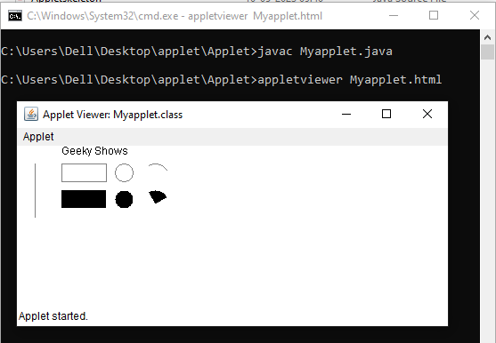

PROGRAM 4.2. An applet program through HTML file.

*import java.applet.*;*

*import java.awt.*;*

*public class Myapplet extends Applet*

*{*

*public void paint(Graphics g)*

*{*

*g.drawString("Geeky Shows",50,10);*

*g.setColor(Color.GRAY);*

*g.drawLine(20,20,20,80);*

*g.drawRect(50,20,50,20);*

*g.drawOval(110,20,20,20);*

*g.drawArc(140,20,30,30,30,90);*

*g.setColor(Color.black);*

*g.fillRect(50,50,50,20);*

*g.fillOval(110,50,20,20);*

*g.fillArc(140,50,30,30,30,90);*

*}*

*}*

*<!DOCTYPE html>*

*<html>*

*<head>*

*<title>HTML applet tag</title>*

*</head>*

*<body>*

*<APPLET code="Myapplet.class" width="250" height="180"></APPLET>*

*</body>*

*</html>*

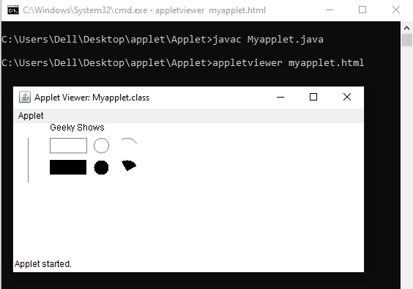

**5. OUTPUT AND DISCUSSION:**

1. An <applet> tag in the comment is created and compiled to run program 4.1 using applet viewer tool.
2. An HTML file is used to run the applet program in program 4.2.
3. To run both program, command prompt is used.

**6. CONCLUSION:**

An Applet program was compiled and executed successfully.